Student Name: Jing Ma

Tuesday Labs

#include "library.h"

//Part 1: What time is it?

/*

void main(){

int date = get_calendar_date();

int time = get_clock_time();

int year = (date/10000);

int month = ((date/100)%100);

int day = (date%100);

//int sec = time%100;

int min = time/100%100;

int hr = time/10000;

print(" year: "); print(year); new_line();

print(" month: "); print(month); new_line();

print(" day: "); print(day); new_line();

print(" hour: "); print(hr); new_line();

print(" minute: "); print(min); new_line();

}

*/

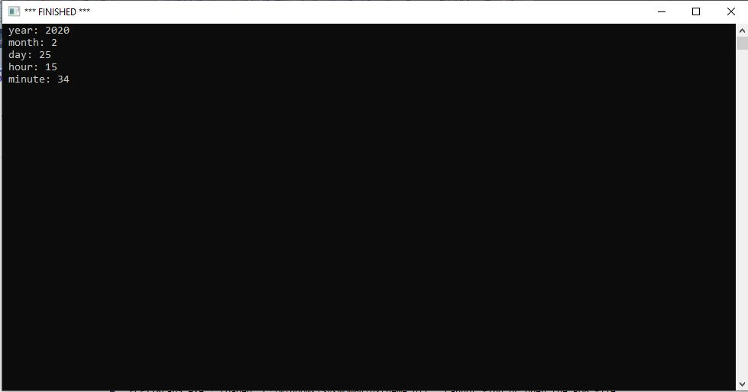

// Part 2: Monroe Doctrine

/*

void am_pm(double hr){

if(hr >= 12){

print(hr-12);

print(" p.m.");

}

else{

print(hr);

print(" a.m.");

}

}

void main(){

int date = get_calendar_date();

int time = get_clock_time();

int year = (date/10000);

int month = ((date/100)%100);

int day = (date%100);

//int sec = time%100;

int min = time/100%100;

int hr = time/10000;

print(" year: "); print(year); new_line();

print(" month: "); print(month); new_line();

print(" day: "); print(day); new_line();

print(" hour: "); am_pm(hr); new_line();

print(" minute: "); print(min); new_line();

}

*/

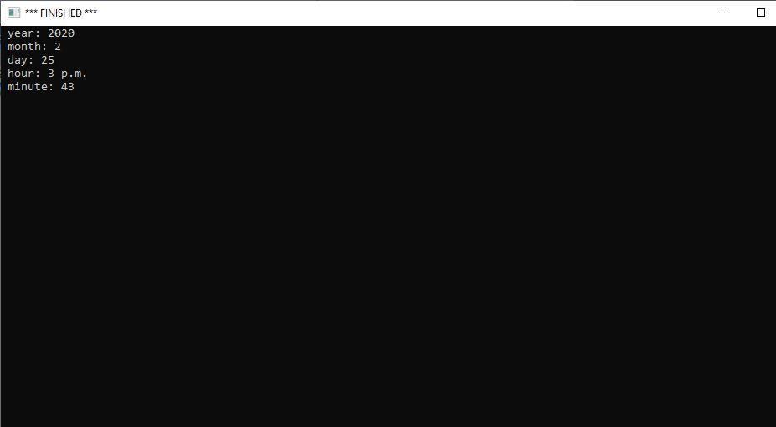

//Part 3: Clock Face

/*

void draw_ticks(double const n, double const degree){

if(n <= 12){

move_to(200,175);

set_pen_width(2);

set_heading_degrees(degree);

move_distance(115);

draw_distance(10);

draw_ticks(n+1, degree+30);

}

}

void draw_square(){

move_to(65, 40);

set_pen_width(1);

set_heading_degrees(90);

draw_distance(270);

turn_right_by_degrees(90);

draw_distance(270);

turn_right_by_degrees(90);

draw_distance(270);

turn_right_by_degrees(90);

draw_distance(270);

}

void main(){

make_window(400, 550);

draw_square();

draw_ticks(1,0);

}

*/

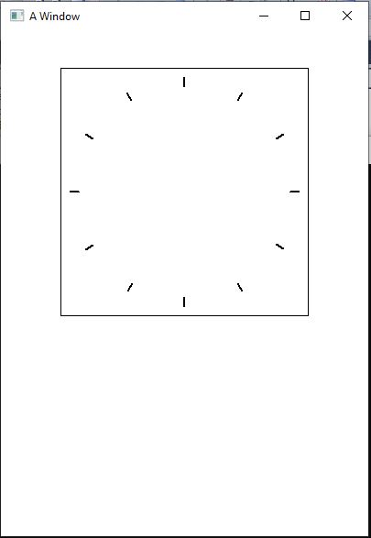

//Part 4: A whole clock

/*

void draw_ticks(double const n, double const degree){

if(n <= 12){

move_to(200,175);

set_pen_width(2);

set_heading_degrees(degree);

move_distance(115);

draw_distance(10);

draw_ticks(n+1, degree+30);

}

}

void draw_hands(){

int date = get_calendar_date();

int time = get_clock_time();

int year = (date/10000);

int month = ((date/100)%100);

int day = (date%100);

int sec = time%100;

int min = time/100%100;

int hr = time/10000;

move_to(200,175);

set_heading_degrees((6*hr*5)+(.5*min));

set_pen_color(color::black);

set_pen_width(5);

draw_distance(50);

move_to(200,175);

set_heading_degrees(6*min);

draw_distance(75);

}

void draw_square(){

move_to(65, 40);

set_pen_width(1);

set_heading_degrees(90);

draw_distance(270);

turn_right_by_degrees(90);

draw_distance(270);

turn_right_by_degrees(90);

draw_distance(270);

turn_right_by_degrees(90);

draw_distance(270);

}

void main(){

make_window(400, 550);

draw_square();

draw_hands();

draw_ticks(1,0);

}

*/

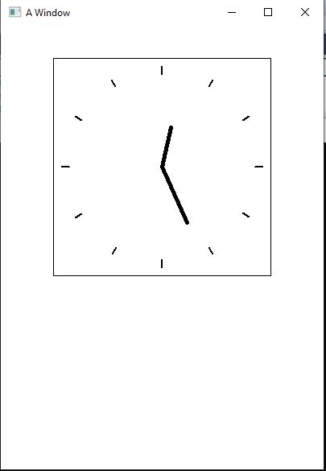

//Part 5: Animate Your Clock

/*

void draw_ticks(double const n, double const degree){

if(n <= 12){

move_to(200,175);

set_pen_width(2);

set_heading_degrees(degree);

move_distance(115);

draw_distance(10);

draw_ticks(n+1, degree+30);

}

}

void draw_hands(){

int date = get_calendar_date();

int time = get_clock_time();

int year = (date/10000);

int month = ((date/100)%100);

int day = (date%100);

int sec = time%100;

int min = time/100%100;

int hr = time/10000;

move_to(200,175);

set_heading_degrees((6*hr*5)+(.5*min));

set_pen_color(color::black);

set_pen_width(5);

draw_distance(50);

move_to(200,175);

set_heading_degrees(6*min);

draw_distance(75);

move_to(200,175);

set_pen_width(1);

set_pen_color(color::red);

set_heading_degrees(6*sec);

draw_distance(90);

set_pen_color(color::black);

}

void draw_square(){

move_to(65, 40);

set_pen_width(1);

set_heading_degrees(90);

draw_distance(270);

turn_right_by_degrees(90);

draw_distance(270);

turn_right_by_degrees(90);

draw_distance(270);

turn_right_by_degrees(90);

draw_distance(270);

}

void animate_clock(){

while(true){

draw_square();

draw_ticks(1,0);

draw_hands();

wait(.2);

clear();

}

}

void main(){

make_window(400, 550);

animate_clock();

}

*/

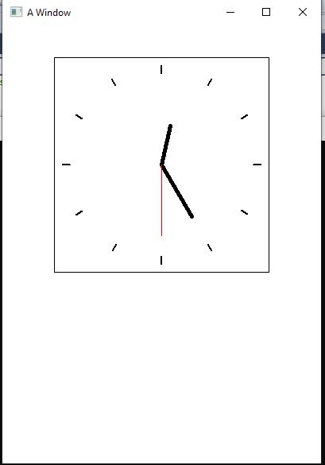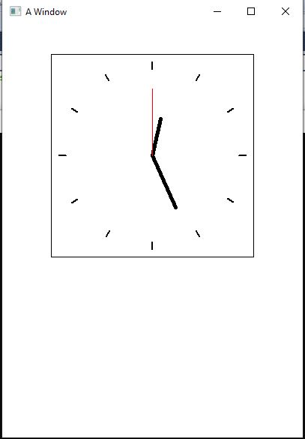

//Part 6: A Complete Product

/*

void draw_ticks(double const n, double const degree){

if(n <= 12){

move_to(200,175);

set_pen_width(2);

set_heading_degrees(degree);

move_distance(115);

draw_distance(10);

draw_ticks(n+1, degree+30);

}

}

void draw_hands(){

int date = get_calendar_date();

int time = get_clock_time();

int year = (date/10000);

int month = ((date/100)%100);

int day = (date%100);

int sec = time%100;

int min = time/100%100;

int hr = time/10000;

move_to(200,175);

set_heading_degrees((6*hr*5)+(.5*min));

set_pen_color(color::black);

set_pen_width(5);

draw_distance(50);

move_to(200,175);

set_heading_degrees(6*min);

draw_distance(75);

move_to(200,175);

set_pen_width(1);

set_pen_color(color::red);

set_heading_degrees(6*sec);

draw_distance(90);

set_pen_color(color::black);

}

void draw_square(){

move_to(65, 40);

set_pen_width(1);

set_heading_degrees(90);

draw_distance(270);

turn_right_by_degrees(90);

draw_distance(270);

turn_right_by_degrees(90);

draw_distance(270);

turn_right_by_degrees(90);

draw_distance(270);

}

void write_date(){

int date = get_calendar_date();

int time = get_clock_time();

int year = (date/10000);

int month = ((date/100)%100);

int day = (date%100);

int sec = time%100;

int min = time/100%100;

int hr = time/10000;

int x = hr - 12;

move_to(155,350);

if(hr>12) write_string(x);

else write_string(hr);

write_string(" : ");

if(min <10){

write_string("0");

write_string(min);

}

else{

write_string(min);

write_string(" ");

}

if(hr >= 12){

write_string("p.m.");

}

else{

write_string("a.m.");

}

move_to(115,370);

write_string(day);

if(day%10 ==1){

write_string("st ");

}

else if(day%10 == 2){

write_string("nd ");

}

else if(day%10 == 3){

write_string("rd ");

}

else{

write_string("th ");

}

if(month ==1){

write_string("January ");

}

else if( month== 2){

write_string("February ");

}

else if(month == 3){

write_string("March ");

}

else if(month == 4){

write_string("April ");

}

else if(month == 5){

write_string("May ");

}

else if(month == 6){

write_string("June ");

}

else if(month == 7){

write_string("July ");

}

else if(month == 8){

write_string("August ");

}

else if(month == 9){

write_string("September ");

}

else if(month == 10){

write_string("October ");

}

else if(month == 11){

write_string("November ");

}

else{

write_string("December ");

}

write_string(year);

}

void animate_clock(){

while(true){

draw_square();

draw_ticks(1,0);

draw_hands();

write_date();

wait(.2);

clear();

}

}

void main(){

make_window(400, 550);

animate_clock();

}

*/

